JavaScript - notes – Tuesday, April 29 (Chapter 13-Nixon (squirrel book))
JavaScript – client side scripting language
Syntax similar to C (and Java) – like PHP it is weakly typed – type changes when used in a new context
Gained power with the adoption of the Document Object Model (DOM).
<script></script> tag set
<noscript></noscript> - good to include what to do when Javascript is not enabled

Javascript code may be placed in the head or the body of an HTML document. (head is there is critical code that can execute when the page loads and be ready to use in other sections. Also writes meta tags into the head section.)
To include a JS file:
<script type=”text/javascript” src=”script.js”> … </script> // where src path may be relative or absolute
Comments: /* */ or //
Statements: end at end of line w/o semi colon. On same line, use semicolons as separators.
(note: Variable or function references followed by a left paren or bracket need a semi-colon.)

Output:
document.write()
alert()
var ans = prompt()

Variables
Variable names: same as java, reserved words (current and future) basically same as Java
Strings: enclose with single or double quotes, escape sequences as in Java
Access to string functions such as charAt, substr, toUpperCase
+stringvariable converts to numeric if possible, NaN otherwise
Numeric variables (integer and real)
Operators: +, -, *, /, %, ++, -- (precedence as in Java, see pg. 318, override with (), LtoR assoc except, new, ++/--, unary bitwise logical, assignment)
Assignment: =, += numbers and strings, -=, *=, /=, %=
Comparison: ==, !=, >, >=, <, <=
!= = not equal (and of same type)
= = = equal (and of same type)
Logical: &&, ||, !
String concatenation – just like Java (except the +variable operator)

Arrays as in PHP : days = [‘Mon’, ‘Thu’, ‘Fri’]
days[1] = ‘Tue’
pos = [[0, 1, 2], [3, 4, 5], [6, 7, 8]]
can also create an array
arrayname = new Array()
or arrayname = []
To add things to this array (or length zero)
arrayname.push(“cat”);
arrayname.push(“dog”) // pushes to end of array
arrayname.pop() to delete from end or arrayname.shift() to delete from beginning
document.write(days[0]) // index from 0
document.write(pos[0][1])
arrayname.splice(1,2) // start at position 1(second el) and delete 2 elements
arrayname.splice(2,0,”item1”, “item2”) // adds item1 and item2 just after second element
// second parameter = 0 means insert, when non-zero, delete that many items and replace

Controlling Program Flow:

If, switch, conditional, while, do while, for, break, continue (as in Java, PHP)

Functions:
function product(a, b)
return a * b
}

Variable scope:
- variable declared outside a function a = 23
- var b = 27
- if a = 27 if (a==5) var c = 789

Arguments array – part of every function allows variable length argument list.
Number of arguments: functionname.arguments.length
Items available as functionname.arguments[i]
Foreach

DOM (document object model)

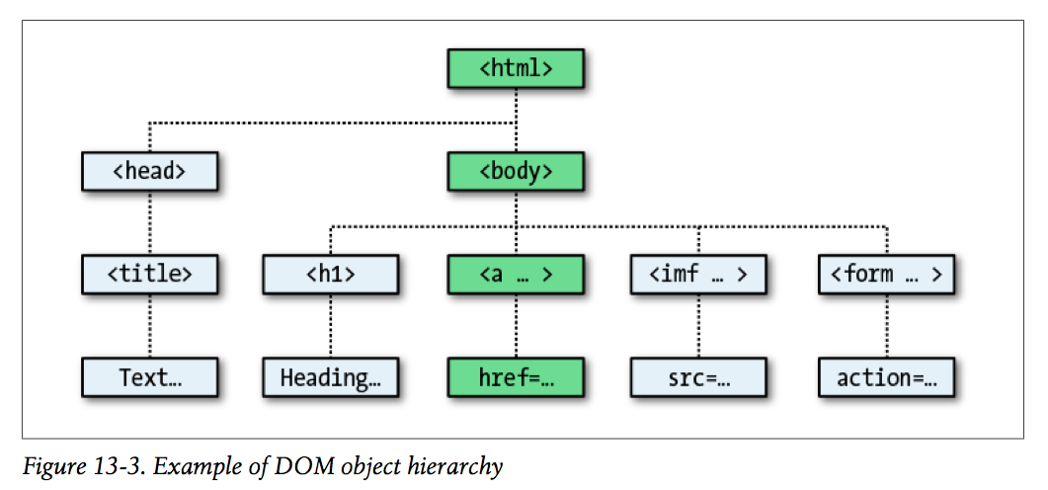

<body>
<a id=”mylink” href=http://google.com >Click here</a>
<script>
url = mylink.href // also document.link.mylink.href
document.write("<br />"+ url)
</script>
</body>

// also document.getElementById(‘mylink’) or document.getElementsByType(‘a’);
JQuery is a cross-platform JavaScript library designed to simplify the client-side scripting of HTML.

Traditional DOM:
var photo = document.getElementById(‘photo’)
photo.src = ‘images/Igor.jpg’

JQuery:
$(‘#photo’).attr(‘src’,’images/Igor.jpg’);

var newphoto = new Image();
newphoto.src = 'images/Igor.jpg';
$(document).ready(function(){
var oldSrc=$('#myimg').attr('src');
$('#myimg').mouseover(function(){
$(this).attr('src', newphoto.src);
});
});

