Student Conduct While Abroad

Eckerd’s “campus” extends to overseas, because it is an academic program.

* Behavioral standards apply

EC-Book: Code of Conduct policies

* Report incidents in timely manner: email global education AND complete incident report (within 8 hours)

Incident Reports – If a behavioral incident occurs abroad, document everything & every conversation

Complete an Incident Reporting Form (web based)** <https://cm.maxient.com/reportingform.php?EckerdCollege&layout_id=0>

* **Minor Incidents** (late, poor attitude, disrespectful, etc.)

First Incident: Give warning (must address issue)

Second Incident: Contact Global Ed

* **Significant Incidents** (No Shows, Disruptive Behavior, etc.)

Address behavior, review expectations

Explain any other incident – student goes home;

Contact Global Ed – state everything in email

* **Major Incidents** (threat to self/others, Title IX, etc.)

Contact Global Ed (call/text) immediately AND email

Seek assistance in country (if applicable)

**\*\*NOTE: On the incident form, be sure to indicate in the “Nature of this Report” field, that this is a “Study Abroad Concern.”**

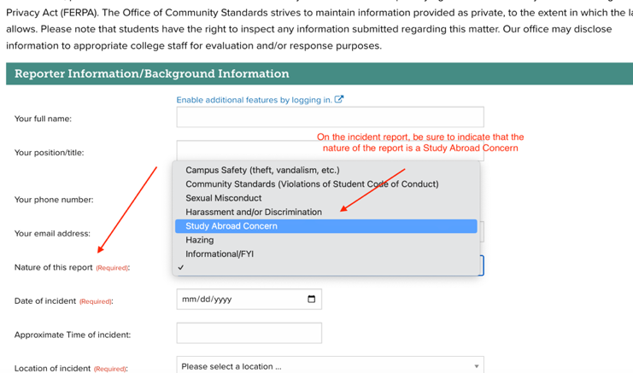

**Office of Global Education**

**Email:** [**globaled@eckerd.edu**](mailto:globaled@eckerd.edu)

**Phone: 727-864-8381**

**After hours cell phone: 727-804-9550**